# Unit 1 - Lesson 5. Assets, Rotations and First Project

**Aim:** How do we apply the trig knowledge in 3D video game programming?

**Objectives:** After the lesson, students should be able to:

* Apply unit circle, sine, cosine in rotating gameObjects
* Apply trig functions in changing the orbit
* Obtain basic knowledge of math modeling in 3-D video game programming
* Get familiar with the Unity UI menus
* Know the differences between the Unity methods of void update() and void fixedUpdate()

**CLASS PROCEDURE:**

***Do Now:***

Open Unity, create a new scene. Add a 3D plane, a sphere and a capsule to the scene. Place the sphere in the center of the plane and then the capsule above the sphere.

1. How can we write a scrip to make the capsule spin in different directions?
2. How can we write a script to make the capsule rotate around the sphere?

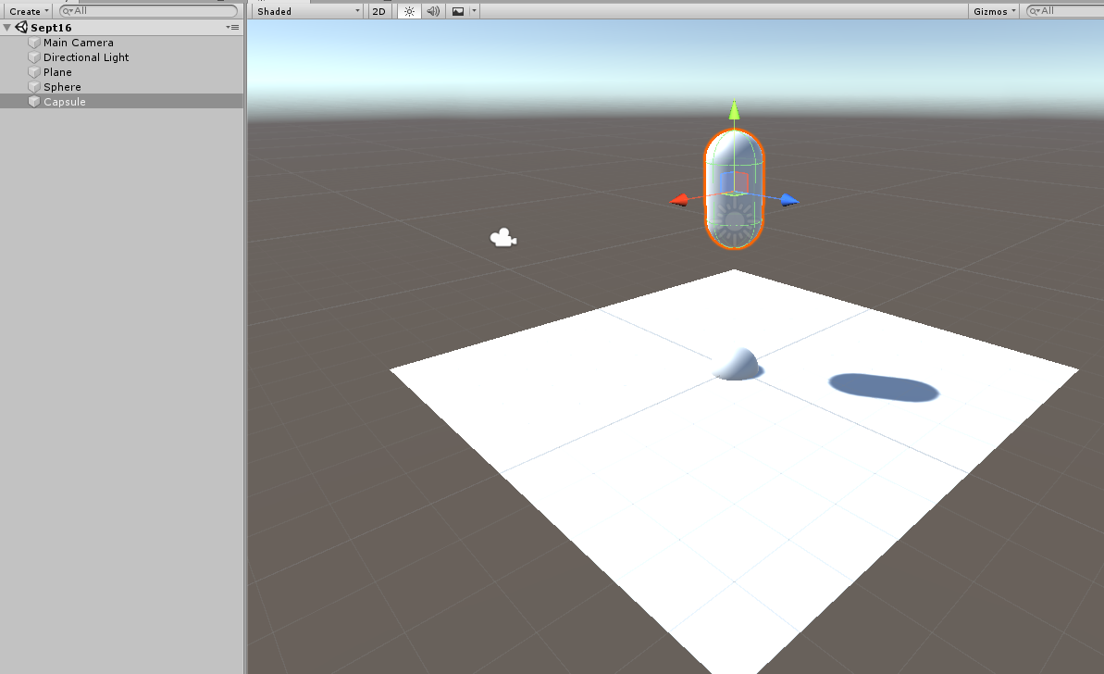

***Discussions / Presentations:***

1. Review of the “Do Now”
2. What are the different methods to make a GameObject spins and rotates?
3. How do import different assets?
4. How do we create a terrain?
5. How do we work with the terrain and imported assets?

***Pair – sharing Activity #1:***

Create a new scene. Import some assets from the Asset Store to create an earth, a tree on the earth and a moon. Make the moon rotate around the earth, and make the moon and the earth spin.

***Pair – sharing Activity #2:***

Start to work on your 1st project. Due: September 27th.